A

PROJECT REPORT

ON

**“ Online Food Ordering System ”**

Towards partial fulfilment of the requirement in

**4th Semester BCA (2023)**

**Submitted by:**

Krishna Rathwa (210510110049)

Dhruv Makwana (210510110022)

Jayesh Gurbani (210510110015)

**Submitted To:-**



**Parul Institute of Computer Application,**

**Parul University.**

Under the guidance of

SOHIL PARMAR

**Acknowledgement**

*The success and final outcome of this project required a lot of guidance and assistance from many people and we are extremely privileged to have got this all along the completion of our project. All that we have done is only due to such supervision and assistance and we would not forget to thank them.*

*We respect and thank Dr Priya Swaminarayan, Dean, FITCS for providing us an opportunity to do the project work in BCA and giving us all support and guidance, which made us complete the project duly. We are extremely thankful to Mam for providing her support and guidance, although she had busy schedule managing the academic affairs.*

*We would not forget to remember Prof. Hina Chokshi, HOD, BCA department for her encouragement and more over for her timely support and guidance till the completion of our project work.*

*We owe our deep gratitude to our project guide _SOHIL PARMAR _, who took keen interest on our project work and guided us all along, till the completion of our project work by providing all the necessary information for developing a good system.*

*We are thankful to and fortunate enough to get constant encouragement, support and guidance from our Parents, all Teaching staffs of BCA Department which helped us in successfully completing our project work. Also, we would like to extend our sincere esteems to all staff in laboratory for their timely support.*

***Krishna Rathwa (210510110049)***

***Dhruv Makwana (210510110022)***

***Jayesh Gurbani (210510110015)***



PARUL INSTITUTE OF COMPUTER APPLICATION

**CERTIFICATE**

This is to certify that ***Krishna Rathwa, Dhruv Makwana, Jayesh Gurbani____***the student(s) of Parul Institute of Computer Application, has/have satisfactorily completed the project entitled “***_Online Food Ordering System_****”* as a part of course curriculum in BCA / IMCA semester-V for the academic year 2021-2022 under guidance of ***_____SOHIL PARMAR_____.***

Enrollment Number: 210510110049

Enrollment Number: 210510110022

Enrollment Number: 210510110015

|  |  |  |
| --- | --- | --- |
| **Quality of work** | **Grade** | **Sign of Internal guide** |
| **Poor / Average / Good /**  **Excellent** | **B /B+ / A / A+** |  |

Date of submission:

HOD, Principal,

**Prof. Hina Chokshi** **Dr Priya Swaminarayan**

**INDEX**

|  |  |
| --- | --- |
| **Content** | **Page No.** |
| 1. System Requirement Specification |  |
| * 1. Abstract | 1 |
| * 1. System Users | 1 |
| * 1. Modules | 1 |
| * 1. Modules Description | 1 |
| * 1. Hardware / Software Requirement | 2 |
| * 1. Flow Chart | 3 |
| * 1. TimeLine Chart | 4 |
| 1. Technology Description |  |
| * 1. Features and Limitations of New System | 5 |
| 1. Data Flow Diagram |  |
| * 1. Context Level DFD’s | 6 |
| * 1. Level 1 DFD’s | 7 |
| * 1. Level 2 DFD’s | 8 |
| 1. Use Case Diagram | 9 |
| 1. Class Diagram | 10 |
| 1. Activity Diagram | 11 |
| 1. E-R Diagram | 12 |
| 1. Data Dictionary | 13 |
| * 1. Description of Data Dictionary | 13 |
| 1. Form Design (Screenshots Phase 1, 2, 3, 4 and Validation’s Screenshots) | 14,15,16 |
| 1. Future Enhancement | 17 |
| 1. References and Bibliography | 18 |

1. **System Requirement Specification**
   1. **Introduction To SRS**
   2. **Abstract**

This Online Food Order System is in PHP, JavaScript, and CSS. Talking about the features of this system, it contains the admin(manager) section and the user (customer) section. All the editing, updating, managing order details, food items, and restaurants are from the admin section while customers can only go through the site and give orders if want. The design of this system is simple so that the user won’t get any difficulties while working on it.

* + 1. **Description of User Role**
* ADMIN : MANAGE THE USERS AND FOOD CATEGORIES.
* USER : USER CAN ORDERING FOOD ONLINE AND MANAGE

THE CART.

* 1. **Modules**
  2. **Modules Description**

Order Module: We can create, read, update and delete Order from this module.

Food Item Module: All the operations related to Food Item, is managed by this module.

Sales Module: Sales Module is used to manage the Sales.

Delivery Module: It has been developed for managing the Delivery Payment Module: It manages the Payment

Customer Module: Customer operations will be managed by Customer module

* 1. **Hardware Requirements**

|  |  |
| --- | --- |
| **Name of Components** | **Specification** |
| Processor | Intel core I5 |
| RAM | 8GB |
| Hard Disk | 512/1 TB |

**3.6. Software Requirements**

|  |  |
| --- | --- |
| **Name of Components** | **Specification** |
| Operating System | Windows XP, Windows 10,11 |
| Software development Kit | Google Chrome, Internet Explorer, Mozilla Firefox (any appropriate or suitable browser |
| Tools & languages | PHP, HTML , JAVASCRIPT |

**Flow Chart**

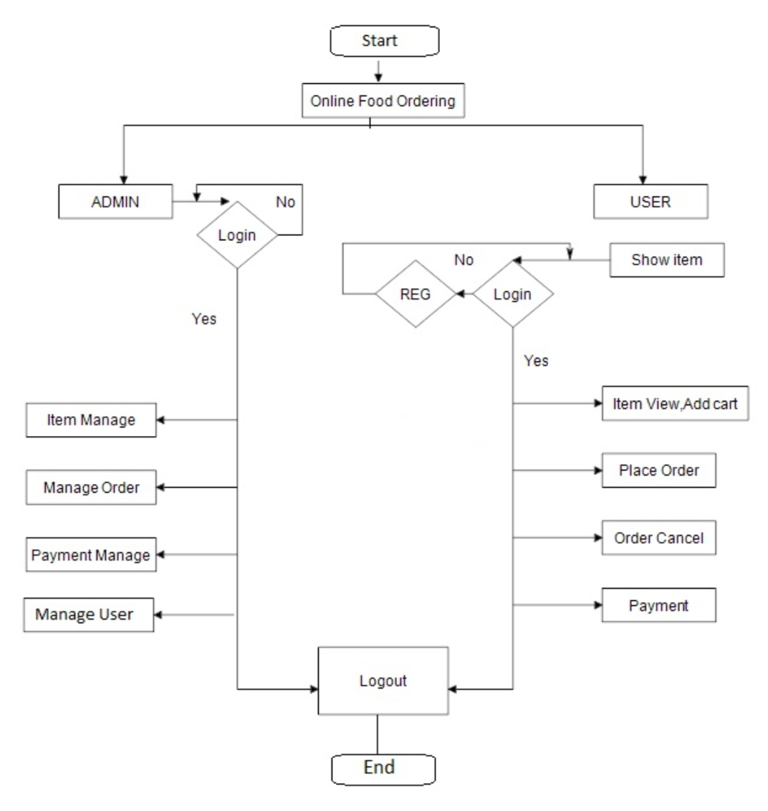

Figure 1.6 Flow Chart

**Time Line Chart**

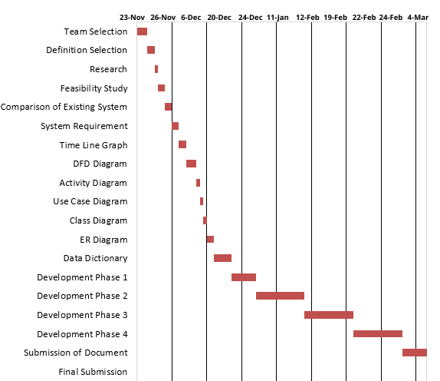

Figure 1.7 Time Line Chart

1. **Technology Description**
   1. **Features and Limitations of New System**

|  |  |
| --- | --- |
| **Limitation** | **Features** |
| Minimum order price range | 50+ NEW ADDITIONAL MENU |
|  | 15 KM RADIUS ZONE |

1. **Data Flow Diagram**
   1. **Context Level DFD’s**

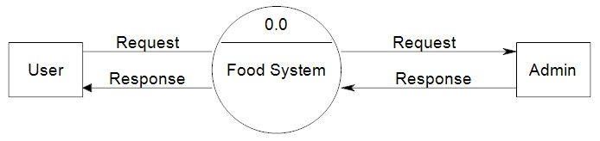

Figure 3.1 0 Level DFD

* 1. **Level 1 DFD’s:**

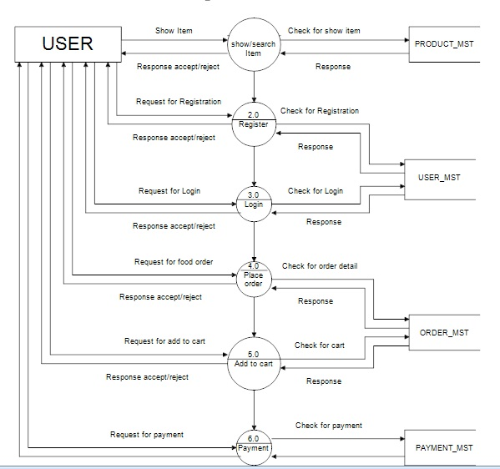

Figure 3.1 1st Level DFD

**Level 2 DFD’s**

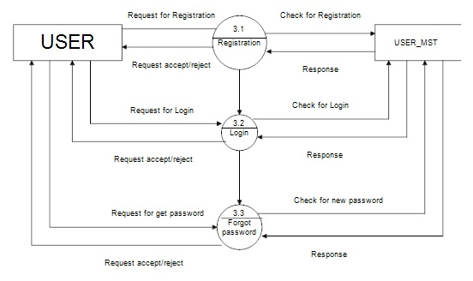

Figure 3.1 2nd Level DFD

1. **Use Case Diagram**

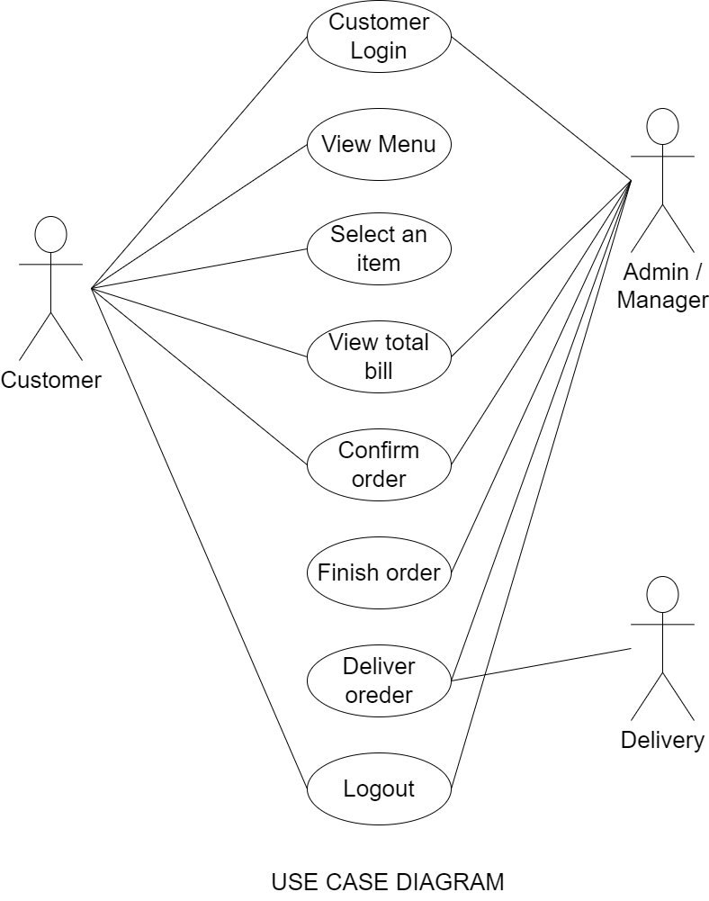

Figure 4 Use Case Diagram

1. **Class Diagram**

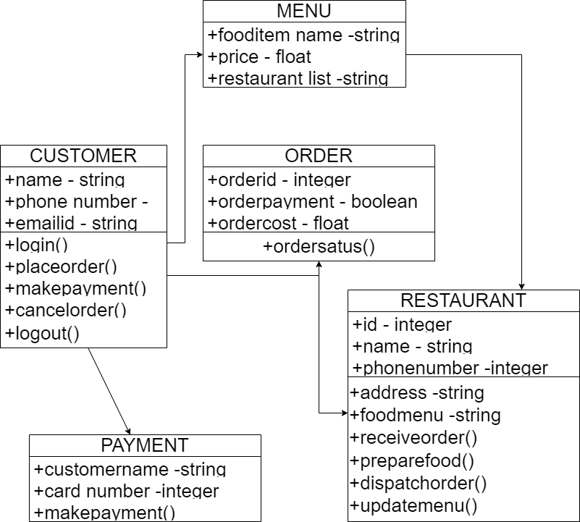

Figure 5 Class Diagram

1. **Activity Diagram**

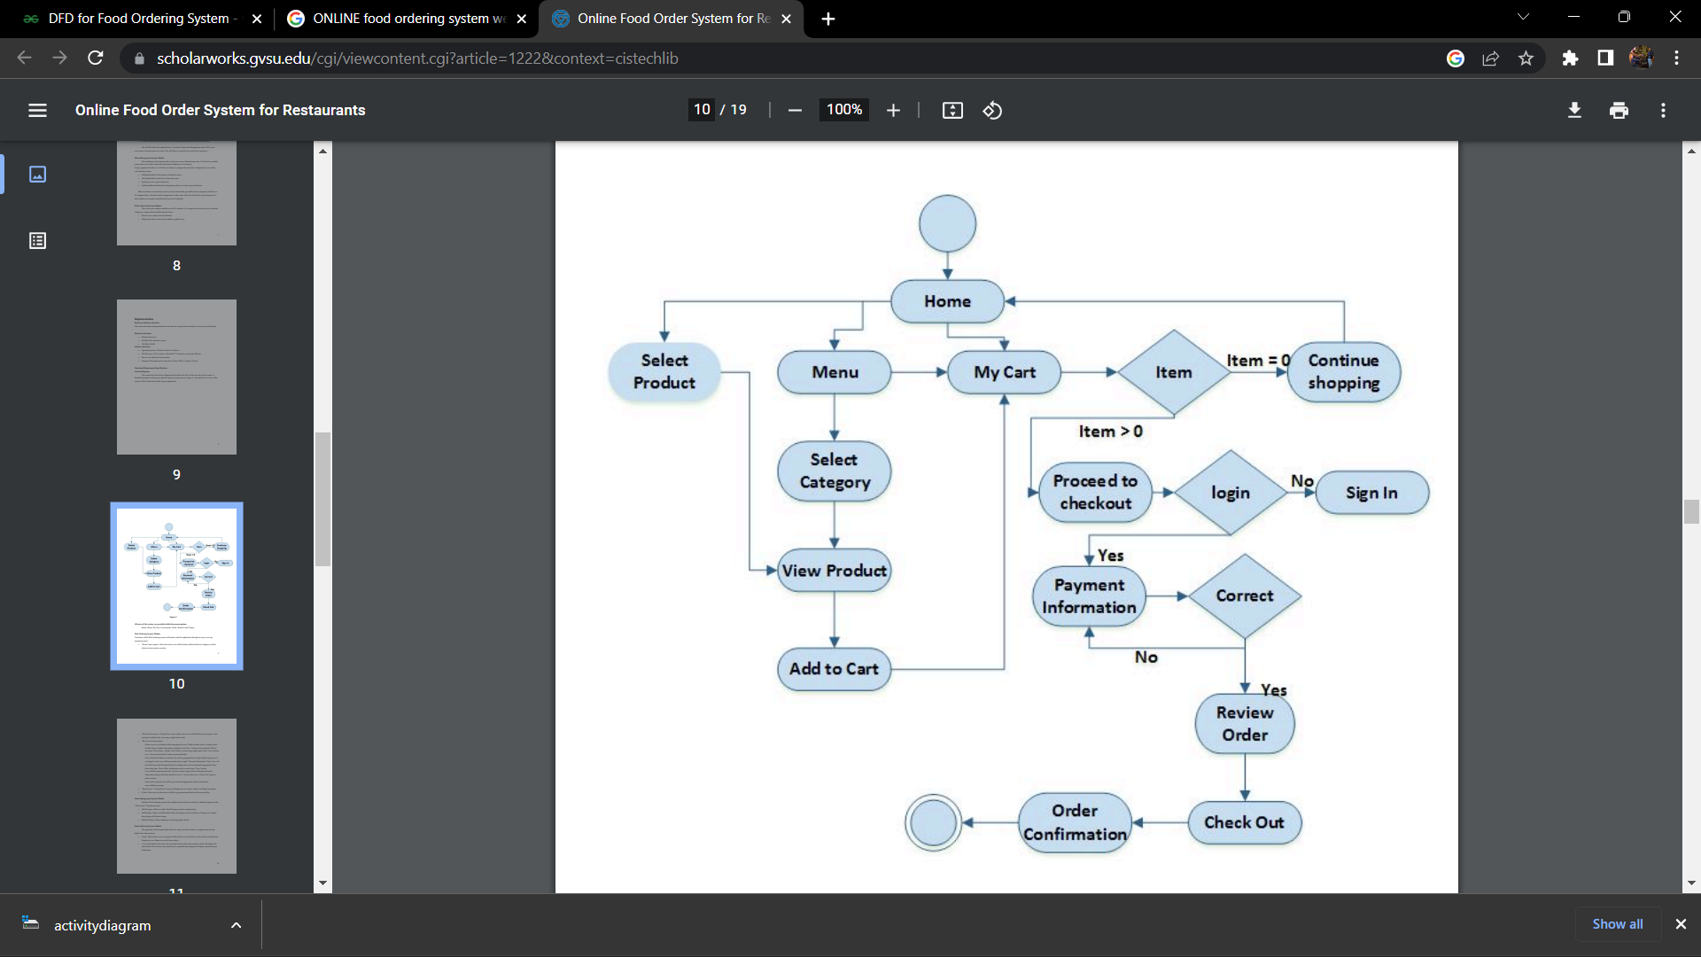

start

End

Figure 6 Activity Diagram

1. **E-R Diagram**

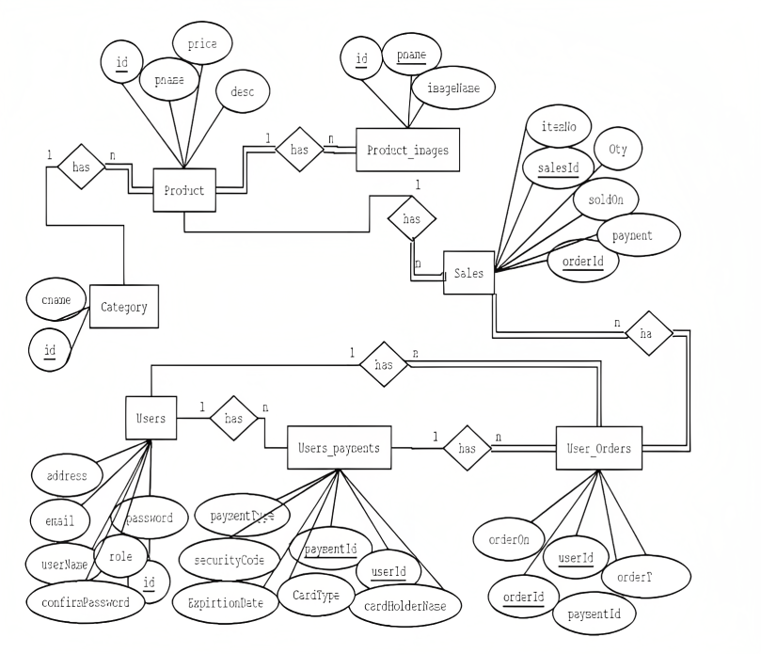

Figure 7 E-R Diagram

1. **Data Dictionary**
2. **Table Name: TTF DATA**
3. **Table Description:**

|  |  |  |  |  |  |  |
| --- | --- | --- | --- | --- | --- | --- |
| **Sr. No** | **Field Name** | **Datatype** | **Size** | **Description** | **Constraint** | **Example** |
| 1 | USERNAME | VARCHAR | 30 | - |  | GHOST01 |
| 2 | FULL NAME | VARCHAR | 30 | - |  | KRISHNA RATHWA |
| 3 | F_ID | INT | 30 |  |  | 22 |
| 4 | PRICE | INT | 30 |  |  | $199 |
| 5 | ORDER_ID | INT | 30 |  |  | 020120231 |
| 6 | ORDER_DATE | DATE | - |  |  | 02-01-2023 |

1. **Form Design (Screenshots Phase 1 ,2,3,4 & validation’s screenshots)**
   1. **Development Phase -1**

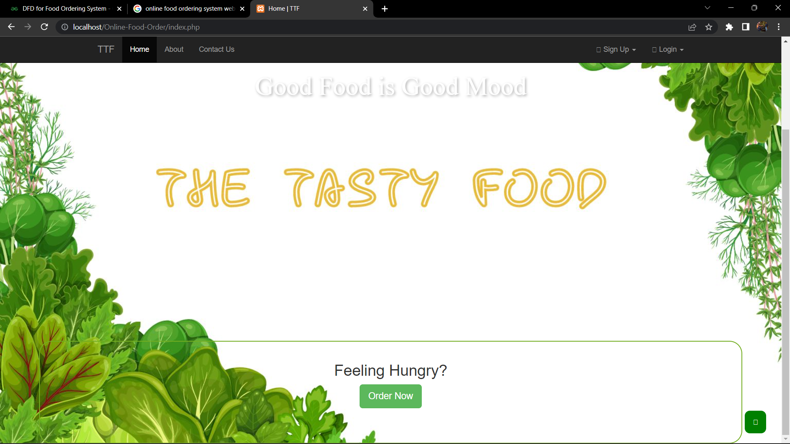

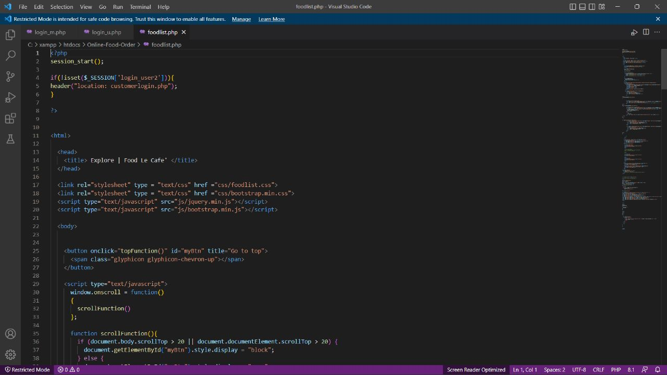

* 1. **Development Phase -2**

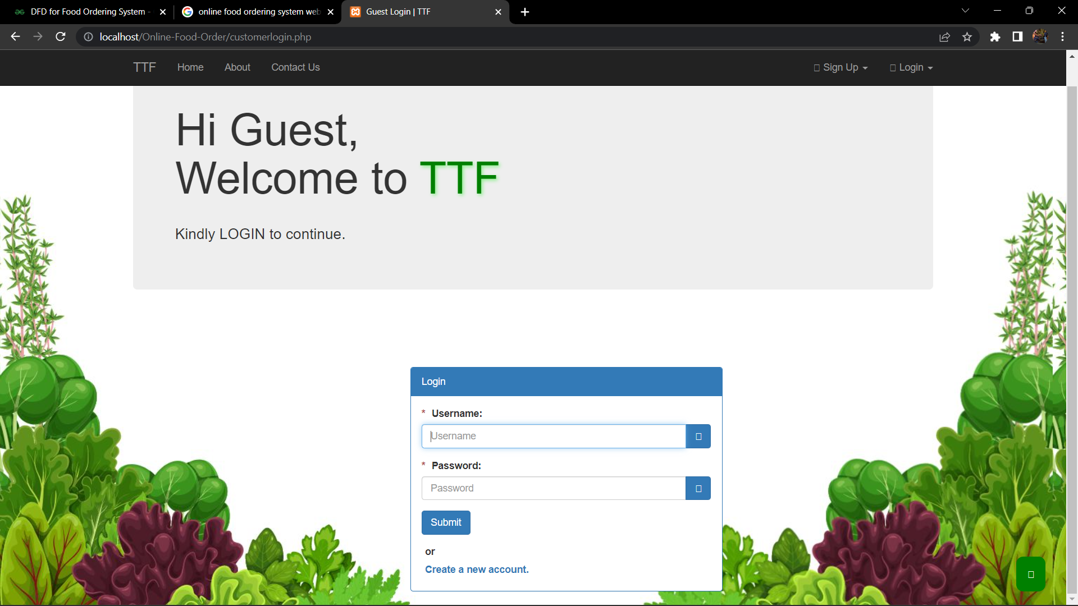

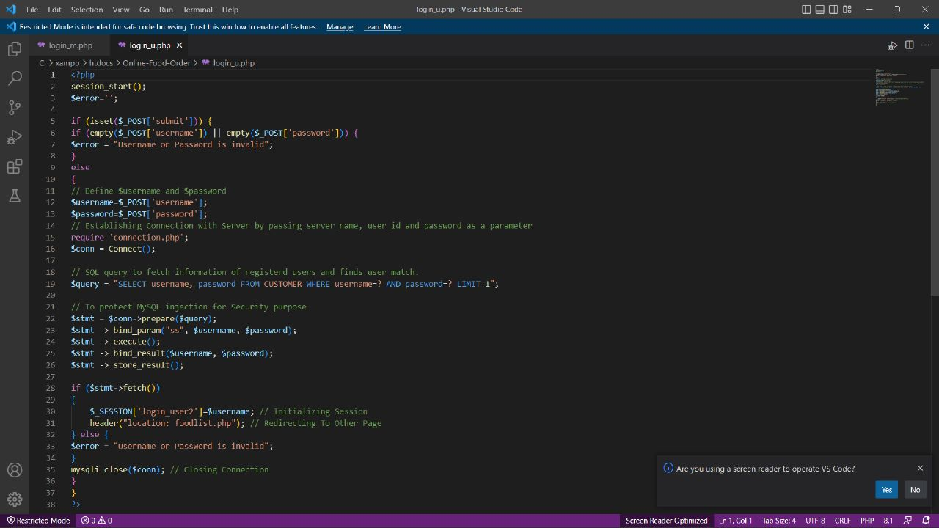

* 1. **Development Phase -3**

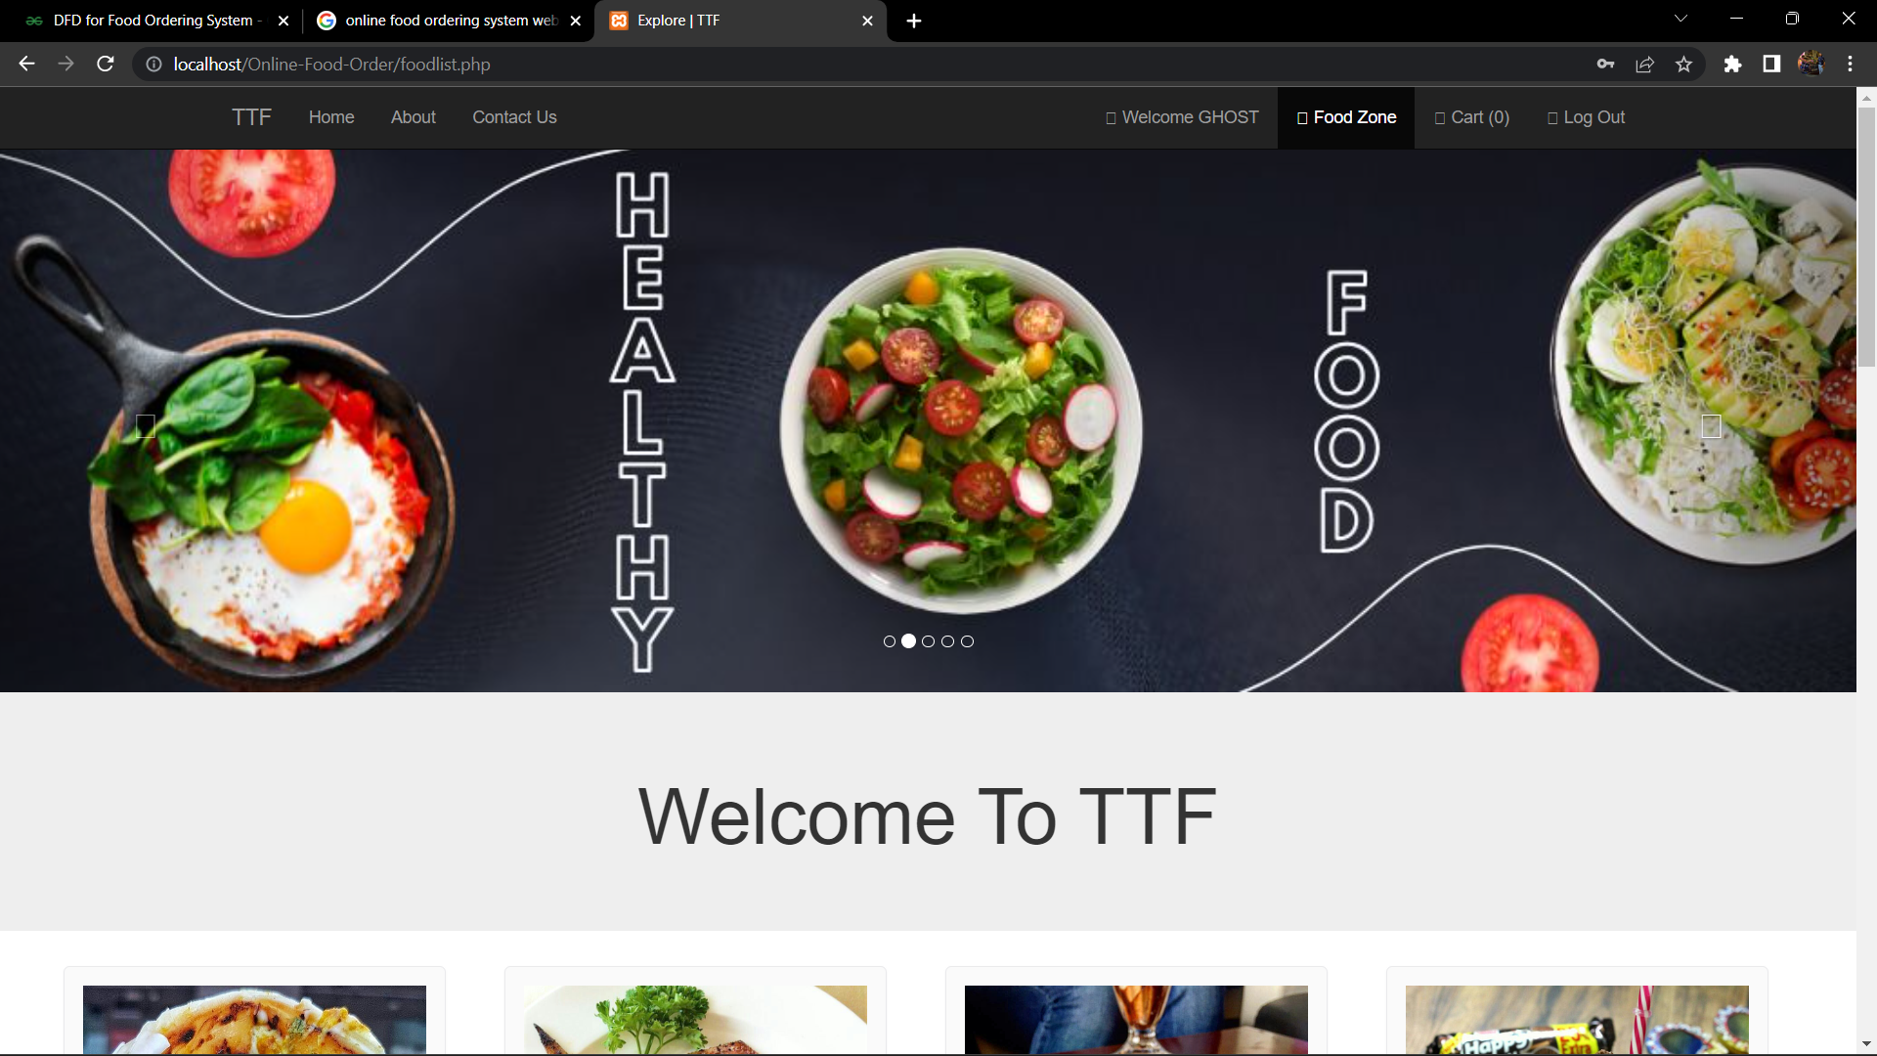

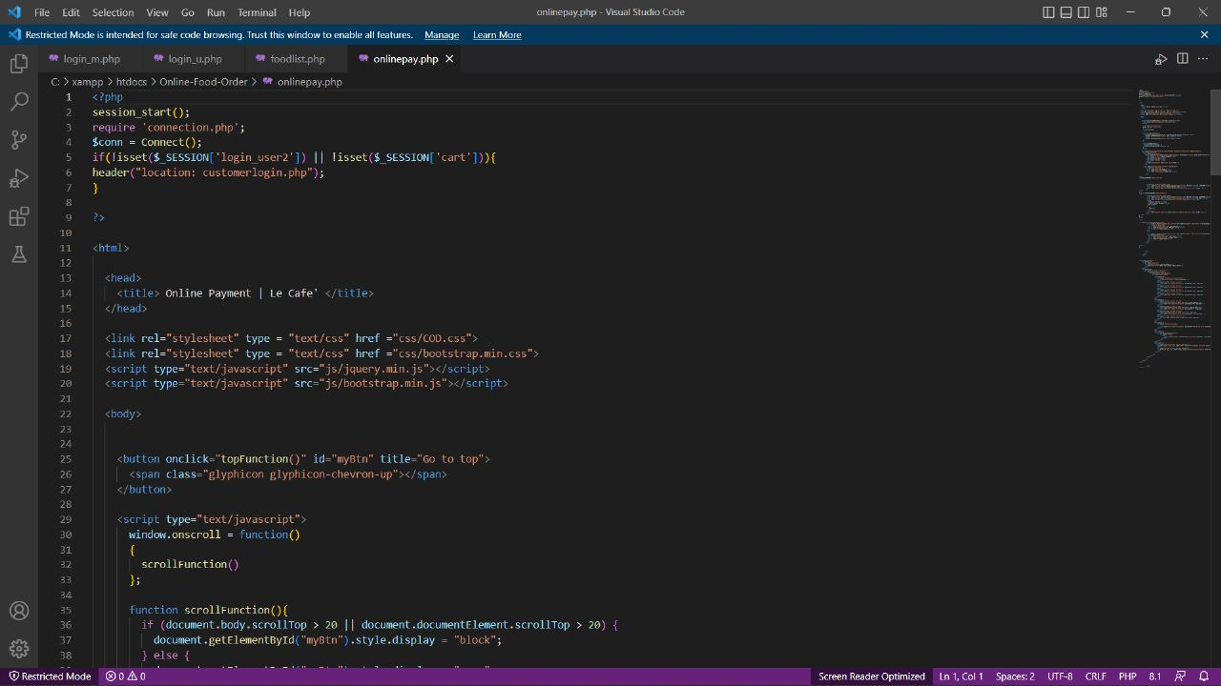

**10. Future Enhancement**

Voice Ordering: Implementing voice-activated virtual assistants to allow customers to place orders hands-free, enhancing the customer experience and providing convenience.

Real-time Order Tracking: Providing real-time order tracking, from the kitchen to the customer's doorstep, allowing customers to have complete visibility of their order status.

**11. References and Bibliography**

1. The Business of Food: Encyclopedia of the Food and Drink Industries" by Gary J. Allen - This book provides a comprehensive overview of the food and drink industries, including online food ordering systems.
2. The Ultimate Guide to Online Food Ordering: How to Create an Online Ordering System for Restaurants" by Andrew Volchek - This book provides a step-by-step guide to creating an online food ordering system for restaurants, including information on the technology, marketing, and operational aspects of such a system.
3. Google
4. W3School